From Maureen Williamson, Reg. N
ONA Local 70 President
WE ARE STRONGER TOGETHER !!
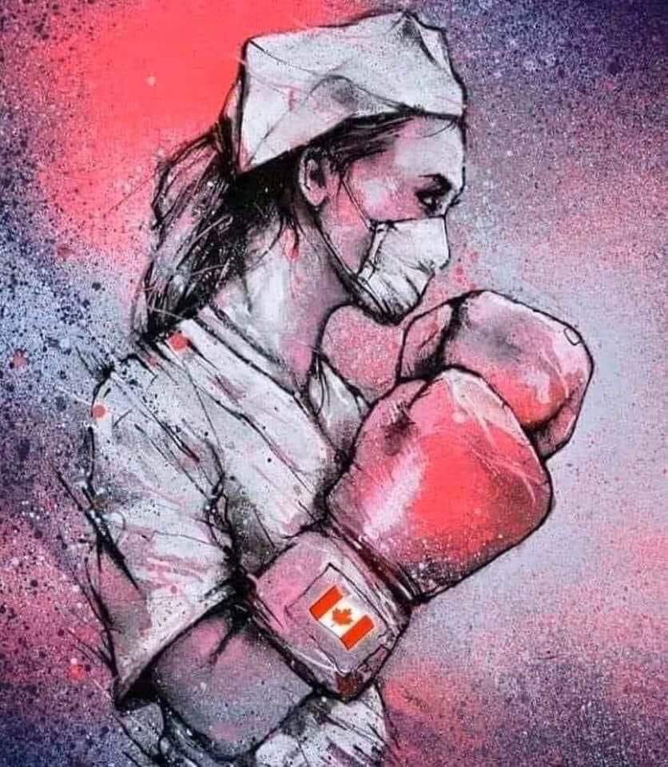
Good day everyone!
I thank you for taking the time to read this.
PCRA
POINT OF CARE RISK ASSESSMENT
This is a very important part of our practice, ever, always has been…..COVID-19 does not change this!
(regardless of directions put forth to us, we decide based on our assessments, if & what PPE is required for us to safely perform out work)
COVID-19
Ongoing issues, frequent updates & changes. I can’t stress enough that we need to keep updated via the ONA website (www.ona.org), the Local 70 website (www.local70.onalocal.org) & the HHS Hub
Our ONA Provincial President, Vicki McKenna, & her team are well aware of what is happening provincially. They have endless, ongoing, numerous meetings with government officials, the media, etc. as well as the numerous Bargaining Unit Presidents. You have to know they NEVER stop & never will give up the fight for us all !!!
Please, if you have any questions or just want to discuss something further, don’t hesitate to contact your site ONA VP (contact info on our website) or call the office: 905-318-5773
Social media is a wonderful place to chat & share but sometimes, ideas & thoughts can be misconstrued……….don’t fret, let’s talk!!!
From the ONA website in:
“We are aware that Ontario Health has advised employers to collect used N95 and surgical masks and to store these in biohazard bags for potential reprocessing. Given the global shortage of PPE, there is emerging evidence that says there maybe various methods of retaining, sterilizing, reprocessing and reusing PPE, including N95 respirators. Any health-care worker, who is placing an N95 into a container, for potential reuse, should be careful not to be contaminated. At this time, there is no certainty regarding scientific evidence that supports reusing N95 masks. We have advised government that, until there is clear evidence and science on safety, ONA will not consider these options without clear scientific evidence that these masks meet the standards for safe use in health-care settings.”

NEGOTIATIONS
CENTRAL: The interest arbitration before Arbitrator John Stout was April 19 & 20; we expect to receive the final & binding award in about 30 days
LOCAL: negotiations ceased when the COVID-19 pandemic was declared, no updates at this point

NURSES’ WEEK (May 11th week)
We are postponing the pizza/wing night & hope to have this in early fall. Updates always on the Local 70 website

**Our Collective Agreements remain in effect with minimal over-riding of certain language, but only temporarily due to the government emergency orders.
When in doubt, please call the office for discussion……individual situations may differ**

Maureen
April 21, 2020

