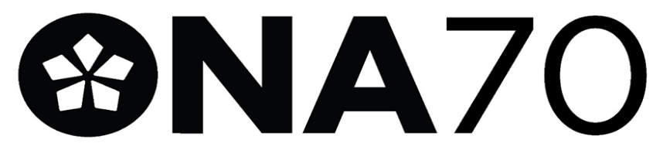

NOMINATION FORM FOR LOCAL 70 Unit Rep – 2023.

(3-year term starting Jan 1, 2024, to December 31st, 2026)

Email form to: Local070sec@ona.org

I nominate__________________________________________ for the position of unit rep.
Please print candidate’s name

Nominator: ________________________________________ __________________________________________
Print Name Signature

Phone: ________________________________________ __________________________________________
ONA Membership Number
Personal Email: ________________________________________

Seconder: ___________________________________ ______________________________________
Print Name Signature

Phone: ___________________________________ ______________________________________
ONA Membership Number

Personal Email: _______________________________

___________________________________________________________________________________________________________

Nomination Accepted by:

_______ ________________________________ _________________________________________________
Print Name Signature

_________________________________________________
ONA Membership Number

Site: _____________________________________ Unit _________________________________________

Phone: _____________________________________ Address: _________________________________________

Personal Email: _____________________________________________________________________________________________

